ARM Student Design Contest 2015

Traffic Info. System

**College Name**- LNMIIT, Jaipur

**Team Members-** Shubham Dangi (1) Ashish Singh(2), Sagar Chand Agarwal(3)

**Project supervisor-** Dr. Abhishek Sharma. Assistant Professor, ECE Engineering

**Abstract-**

We aim to design Machine Learning Based classification algorithms which are simpler and more suitable for an embedded platform, and which can yield road traffic state predictions with better accuracy in India

**Introduction-**

Road traffic conditions in India are getting worse day by day. The average number of vehicles in India is growing at the rate 10.16 percent annually, since last twelve years .The average level of ownership of cars in India, currently 13 per 1,000 population, is expected to grow exponentially. Spending hours in traffic jam has become part and parcel of metropolitan life style, leading to health and environmental hazards.

There could be two approaches to solve this problem. First and the most obvious solution is to come up with infrastructure involving wider roads, bypasses and expressways. But for developing countries like India, money and space are serious concerns. Second approach is to manage existing traffic with same infrastructure, with the use of technology and by involving commuters in the process.

We here, are concentrating on the second approach, that is Intelligent Transportation System (ITS) which makes use of classification techniques to alleviate road traffic problems.

**Advantages of Traffic Information & Classification System-**

1. Enhance Mobility.
2. Safety and Reduce Pollution and Consumption of Energy.
3. Encourage use of Public Transport System.
4. Reduce Traffic Jams.
5. Redirection of routes and sublime traffic flow.

**Implementation of Traffic Information System**

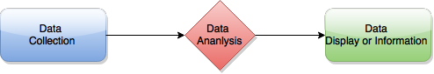

There are two ways of implementation of Traffic Information System:

1: Centralized System (Expensive Sensors technologies and used in mainly developed countries.)

2: Decentralized system

* It is a zero public infrastructure vehicle based traffic information system.
* A traffic situation analysis is performed in each individual vehicle and the result is transferred via wireless data-link to all surrounding vehicles in the local neighborhood.

**(1)-SOTIS (An Implementation of Decentralized System)**

Each vehicle monitors the locally observed traffic situation by recurrently receiving data packets with detailed information from other vehicles. No sensors along the highways, no central units and no broadcast stations or cellular networks are needed. The complete system can be easily deployed and service charges for the end user can be avoided completely.

**Data Collection and Analysis**

The SOTIS system design is based on the following guidelines and technical assumptions:

* The SOTIS technique should be able to provide reliable travel and traffic information for the area that can be reached in the near future by the driver.
* Each SOTIS vehicle is equipped with a satellite navigation receiver (GPS), a digital street map, a simple digital radio and a small data processing unit.
* The SOTIS service should be available at each position, on highways and in cities, at any time.

**Methodology and Display-**

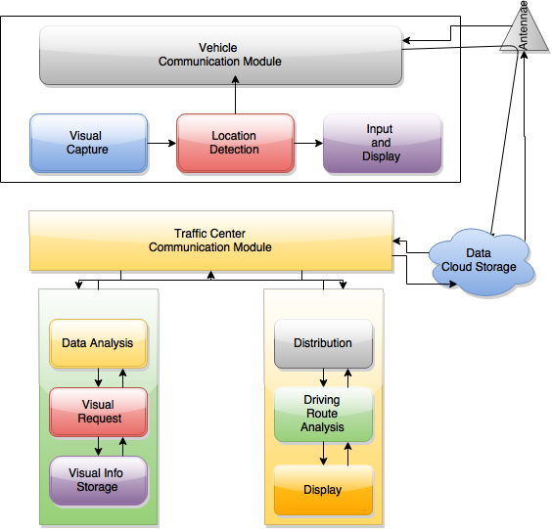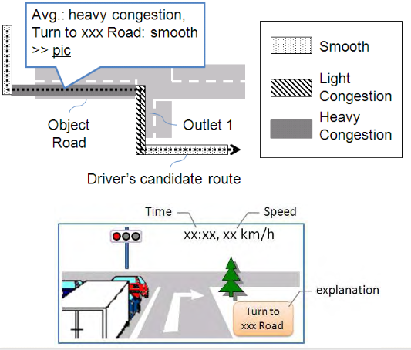 **(2)**

**Future Scope & Conclusion-**

The proposed system yields better results when compared with the individual algorithm results of other Traffic Based Classification System and adds a low cost and efficient alternative system in combating traffic congestion in urban regions of India. The assistive system will be able to meet most of the challenges in client’s everyday life.

**Referenced Documents-**

**(1)** <http://ieeexplore.ieee.org/xpls/abs_all.jsp?arnumber=1208829&tag=1>

**(2)** <http://citeseerx.ist.psu.edu/viewdoc/download?doi=10.1.1.13.9820&rep=rep1&type=pdf>